“Java Software Developer Internship at Incedo Inc.”
A Mid-term Report
Submitted in partial fulfillment of requirement of
B.E. in Information Technology



Mohd Zaid Habib
UE228071
(BE - IT 8TH SEM)

UNIVERSITY INSTITUTE OF ENGINEERING AND TECHNOLOGY
PANJAB UNIVERSITY, CHANDIGARH
2026

DECLARATION

I hereby declare that the project work entitled “Java Software Developer Internship at Incedo Inc.” is an authentic record of my own work carried out at Incedo Inc as requirements of six months project semester for the award of degree of B.E. at University Institute of Engineering & Technology, Panjab University, Chandigarh under the guidance of Ruchi Jain and Sukesha Sharma, during ____________________.

Date: ____________________
Mohd Zaid Habib
UE228071

Certified that the above statement made by the student/trainee is correct to the best of our knowledge and belief.

Sukesha Sharma
Professor Ruchi Jain Manager
Faculty Coordinator Industry Coordinator

Acknowledgement

I would like to express my sincere gratitude to my industry mentor Rama Krishna for providing me the opportunity to work on the project Java Software Developer Internship at Incedo Inc.
I would also like to thank my faculty coordinator Dr. Sukesha Sharma for their continuous guidance and support during my internship training.
I am thankful to University Institute of Engineering and Technology, Panjab University for providing me the opportunity to undertake this internship as a part of my academic curriculum.
Finally, I would like to thank all those who directly or indirectly helped me during the completion of this work

Abstract

This report presents the work carried out during the first phase of my six-month industrial internship at Incedo Inc., from 13 January 2026 to March 2026.
The internship began with an onboarding process followed by extensive technical training in Java, Spring Boot, React, Microservices, DevOps, and AWS Cloud technologies. During this training period, I learned important software development concepts including object-oriented programming, database management, RESTful API development, containerization using Docker, and frontend development using React.
As part of the hands-on learning activities, a Gym Management System project was developed to apply full-stack development concepts and understand the architecture of enterprise applications.
In addition to technical training, I also completed domain knowledge sessions related to retail banking and financial systems, covering topics such as retail lending, payment systems, financial risk management, anti-money laundering, and financial fraud prevention.
Currently, I am undergoing Agentic AI training on AWS, where I have completed the prerequisite learning modules related to Generative AI and Agentic AI foundations.
This report summarizes the learning activities, technologies studied, domain knowledge acquired, and the progress made during the first two months of the internship.

Introduction to the Industry

Incedo Inc. is a global digital transformation and technology consulting company that focuses on data engineering, artificial intelligence, cloud computing, and digital product engineering.
The company provides technology solutions to industries such as:
- Banking and Financial Services
- Telecommunications
- Healthcare
- Retail and E-commerce
Incedo helps enterprises modernize their systems by building cloud-native, AI-powered, and data-driven applications. The company emphasizes innovation in areas such as machine learning, generative AI, cloud infrastructure, and digital platforms.
Through structured internship programs, Incedo provides students with exposure to modern software development practices, cloud technologies, and emerging AI solutions.

Work / Problem Assigned
The key activities included:
• Learning Java programming and object-oriented design
I studied the fundamentals of Java programming including data types, control structures, methods, and exception handling. I also learned core object-oriented programming concepts such as encapsulation, inheritance, polymorphism, and abstraction.
• Developing backend applications using Spring Boot
I learned to build backend applications using the Spring Boot framework. This included creating REST APIs, managing databases using Spring Data JPA, and implementing validation and exception handling.
• Building frontend applications using React
I developed user interfaces using React by learning concepts such as components, props, state, and React hooks. I also implemented routing and integrated frontend applications with backend APIs.
• Understanding microservices architecture
I studied the fundamentals of microservices architecture where applications are divided into smaller independent services. I learned how services communicate using APIs and how distributed systems improve scalability and maintainability.
• Learning DevOps practices and containerization
I gained basic knowledge of DevOps concepts and containerization using Docker. This included creating Docker images, running containers, and understanding how containerization simplifies application deployment.
• Deploying applications using AWS cloud services
I learned how to deploy applications on cloud infrastructure using Amazon Web Services. This included understanding cloud computing concepts and deploying applications on services such as AWS EC2.
• Gaining financial domain knowledge
I attended training sessions focused on the financial services domain. These sessions covered topics such as retail banking, payment systems, financial risks, and fraud prevention.
• Learning Generative AI and Agentic AI technologies
I also participated in training related to Generative AI and Agentic AI using AWS platforms. This included understanding large language models, AI agents, and their applications in enterprise solutions.

Objectives of the Internship

• To gain practical knowledge of enterprise software development
The internship aims to provide hands-on experience in developing real-world enterprise applications and understanding industry software development practices.
• To learn Java full-stack development technologies
To build a strong foundation in Java-based full-stack development by learning backend and frontend technologies used in modern software systems.
• To understand microservices architecture
To study how large applications are designed using microservices, where systems are divided into smaller, independent services that communicate through APIs.
• To develop applications using Spring Boot and React
To gain practical experience in building backend services using Spring Boot and creating dynamic user interfaces using React.
• To understand cloud deployment using AWS
To learn how applications are deployed, managed, and scaled using cloud computing platforms such as Amazon Web Services.
• To gain knowledge about financial industry domains
To understand the fundamentals of financial systems, banking operations, and industry regulations relevant to enterprise software solutions.
• To explore AI and Agentic AI technologies
To gain exposure to emerging technologies such as Generative AI and Agentic AI and understand their role in modern intelligent applications.

Internship Timeline

Period | Activity
13 Jan – 15 Jan | Onboarding and environment setup
16 Jan – 16 Feb | Java Full Stack Development Training
17 Feb | Technical evaluation
18 Feb – 3 Mar | Domain knowledge training
4 Mar – Present | Agentic AI training on AWS

Technical Training – Java Full Stack Development
During the training phase, several core software development technologies were covered.

Java Programming
The Java training covered both basic and advanced programming concepts including:
- Java fundamentals
- Variables, data types, and operators
- Object-oriented programming
- Exception handling
- Collections framework
- Functional programming and lambda expressions
- Stream API
- Multithreading
- Date and time API

Database and ORM
The training also included database management concepts:
- Relational database architecture
- SQL queries and database design
- Data definition and data manipulation
- JDBC connectivity
- Hibernate ORM framework
- Entity relationships and mappings

Spring Framework and Spring Boot
Backend development training included:
- Dependency Injection and IoC container
- Spring Boot application development
- RESTful web services
- Exception handling
- API documentation using Swagger
- Spring Security
- JWT-based authentication

Microservices Architecture
Microservices concepts included:
- Difference between monolithic and microservices architecture
- Service discovery
- API gateway
- Inter-service communication
- Load balancing
- Configuration management
- Circuit breaker patterns

DevOps and Cloud
The DevOps training included:
- Version control using Git
- Docker containerization
- Docker Compose
- CI/CD pipeline concepts
- Deployment using AWS EC2
- Database hosting using AWS RDS

React Frontend Development
Frontend training focused on building interactive web applications using React.
Topics included:
- React components
- Props and state management
- React hooks
- Routing using React Router
- Form handling
- API communication using Axios
- Redux state management

Project – Gym Management System

1. Project Overview
During the Java Full Stack training phase of the internship, a project titled Gym Management System was developed as a practice project to apply the concepts learned during the training.
The objective of this project was to simulate a real-world enterprise application used for managing gym operations efficiently. The system allows administrators to manage gym members, trainers, attendance records, class bookings, and gym inventory through a structured microservices architecture.
The project was designed using modern full-stack development technologies including Spring Boot for backend services, React for the frontend interface, MySQL for database management, and Docker and AWS for deployment.
This project helped in understanding REST API development, microservices architecture, authentication mechanisms, and cloud deployment practices in a practical development environment.

2. Key Features of the System
The Gym Management System includes several features that help manage different gym operations effectively.
Main features include:
• User authentication and authorization using JWT
• Management of gym members and membership plans
• Trainer management and assignment to members
• Attendance tracking for member check-in and check-out
• Class scheduling and booking system
• Inventory management for gym equipment and assets
These features together create a complete gym management platform capable of handling day-to-day operational tasks.

3. System Architecture
The Gym Management System is built using a microservices-based architecture where the entire system is divided into multiple independent services.
Each service performs a specific task and communicates with other services through APIs.
The system consists of the following microservices:
Microservice | Description
API Gateway | Entry point that routes all client requests to appropriate microservices
Auth Service | Handles user registration, login, and JWT authentication
Member Service | Manages gym members, memberships, and subscription plans
Attendance Service | Tracks member check-in and check-out activities
Trainer Service | Manages trainers and assigns them to members
Class & Booking Service | Handles gym classes, sessions, and member bookings
Inventory Service | Manages gym equipment and maintenance records
The API Gateway acts as a central entry point, ensuring secure and organized communication between clients and backend services.

4. Layered Architecture
Each microservice in the system follows a layered architecture to maintain separation of concerns and improve maintainability.
The main layers include:
• Controller Layer – Handles incoming HTTP requests and exposes REST APIs
• Service Layer – Contains business logic and application rules
• Repository Layer – Manages database interactions using Spring Data JPA
• Entity Layer – Represents database tables using Java classes
• DTO Layer – Used for request and response data transfer
• Exception Handling – Global exception management using @ControllerAdvice
• Security Layer – Handles authentication and authorization using JWT tokens
This architecture ensures that the application remains modular, scalable, and easy to maintain.

5. Technologies Used

Backend Technologies
The backend of the application was developed using the following technologies:
• Java – Core programming language used for application development
• Spring Boot – Framework used for building RESTful web services
• Spring Data JPA – Used for database interaction and ORM mapping
• Spring Security – Provides authentication and authorization features
• JWT (JSON Web Token) – Used for secure API authentication
These technologies enabled the development of secure, scalable, and maintainable backend services.

Frontend Technologies
The frontend interface of the system was built using modern JavaScript technologies.
• React – JavaScript library for building dynamic user interfaces
• Axios – Used for making API requests to backend services
• React Router – Enables navigation between application pages
The frontend interacts with backend APIs to display and manage gym-related data.

Database
The system uses MySQL as the relational database management system.
Each microservice maintains its own database to ensure data isolation and scalability, which is a common practice in microservices architecture.
Separate databases include:
• gym_auth
• gym_member
• gym_attendance
• gym_trainer
• gym_class
• gym_inventory

Deployment Tools
The application was deployed using modern DevOps tools.
• Docker – Used for containerizing applications and ensuring consistent runtime environments
• AWS EC2 – Cloud virtual machines used to host the backend services
• Docker Compose – Used to manage multiple containers for the microservices system
These tools help in deploying applications in cloud environments similar to production systems.

6. Development Workflow
The development of the Gym Management System followed a structured workflow where each microservice was implemented step-by-step.
The general development process included:
- Creating the project structure and dependencies
- Designing database tables and entity models
- Implementing repository interfaces for data access
- Developing service classes containing business logic
- Creating REST controllers for API endpoints
- Implementing security using JWT authentication
- Testing APIs using Postman and Swagger
- Deploying services using Docker and AWS
This approach ensured that each component of the system was developed, tested, and integrated systematically.

7. API Testing
The APIs developed in the system were tested using Postman and Swagger UI.
Typical API workflow included:
- Register a user
- Login and receive JWT token
- Pass JWT token in Authorization header
- Access protected APIs such as member creation, trainer assignment, and attendance tracking
This process ensured that authentication and service communication worked correctly across the microservices architecture.

8.Project Screenshots(Frontend)
1-Login page


2-Home Page

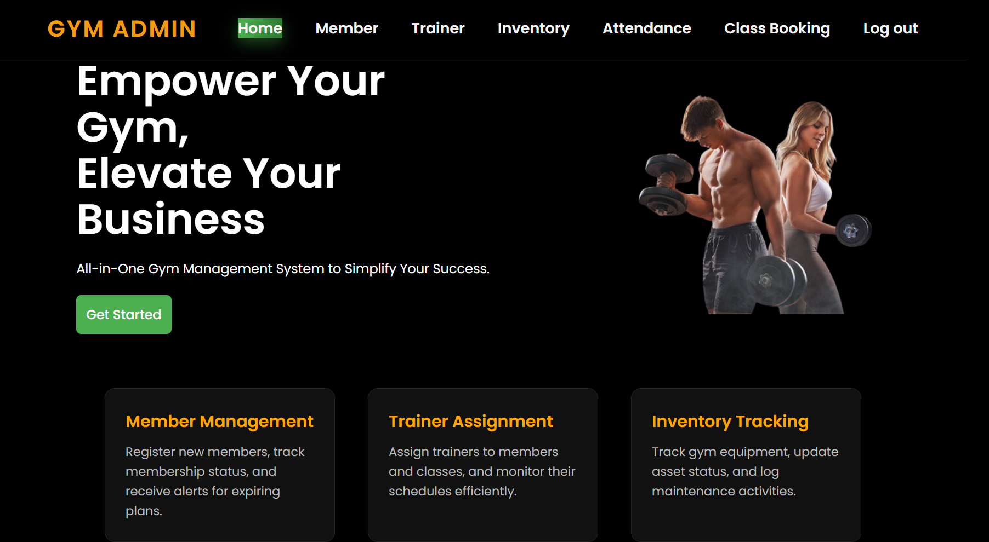

3-Member Page
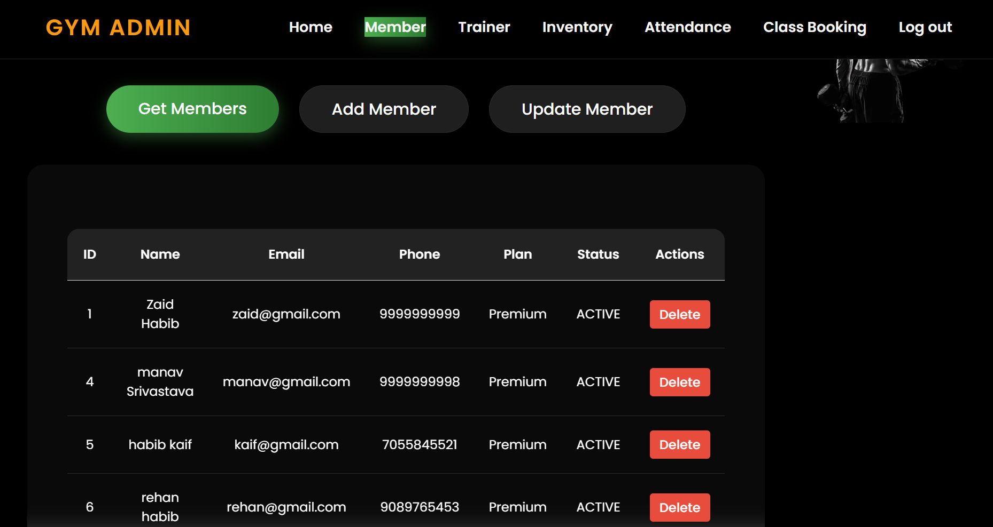

4-Trainer Page
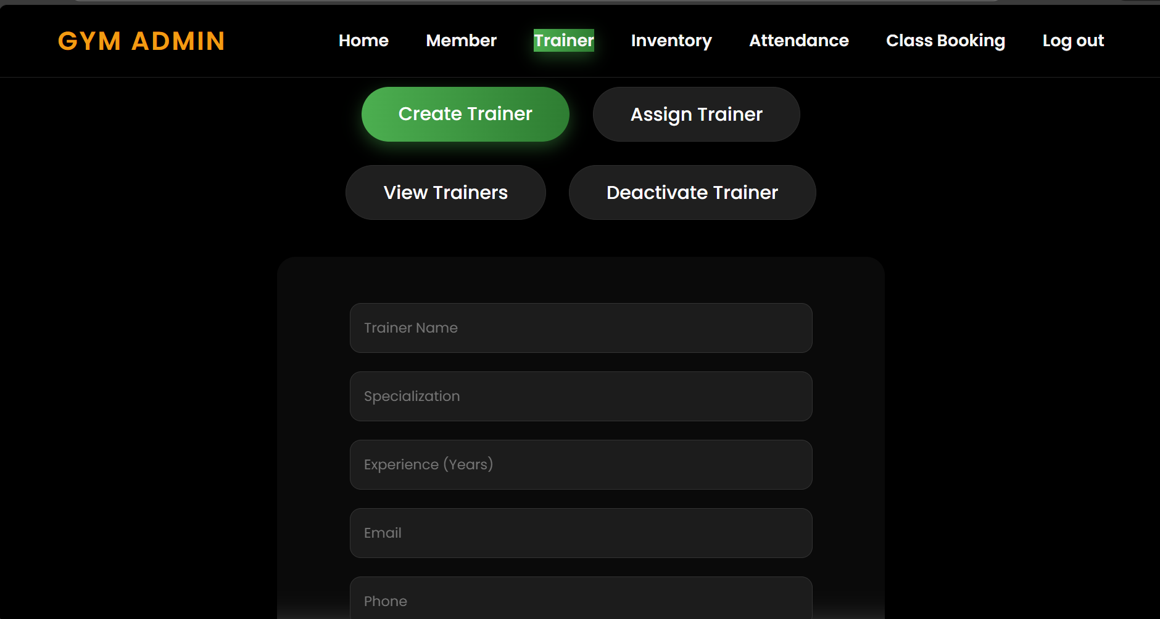
5-Inventory page
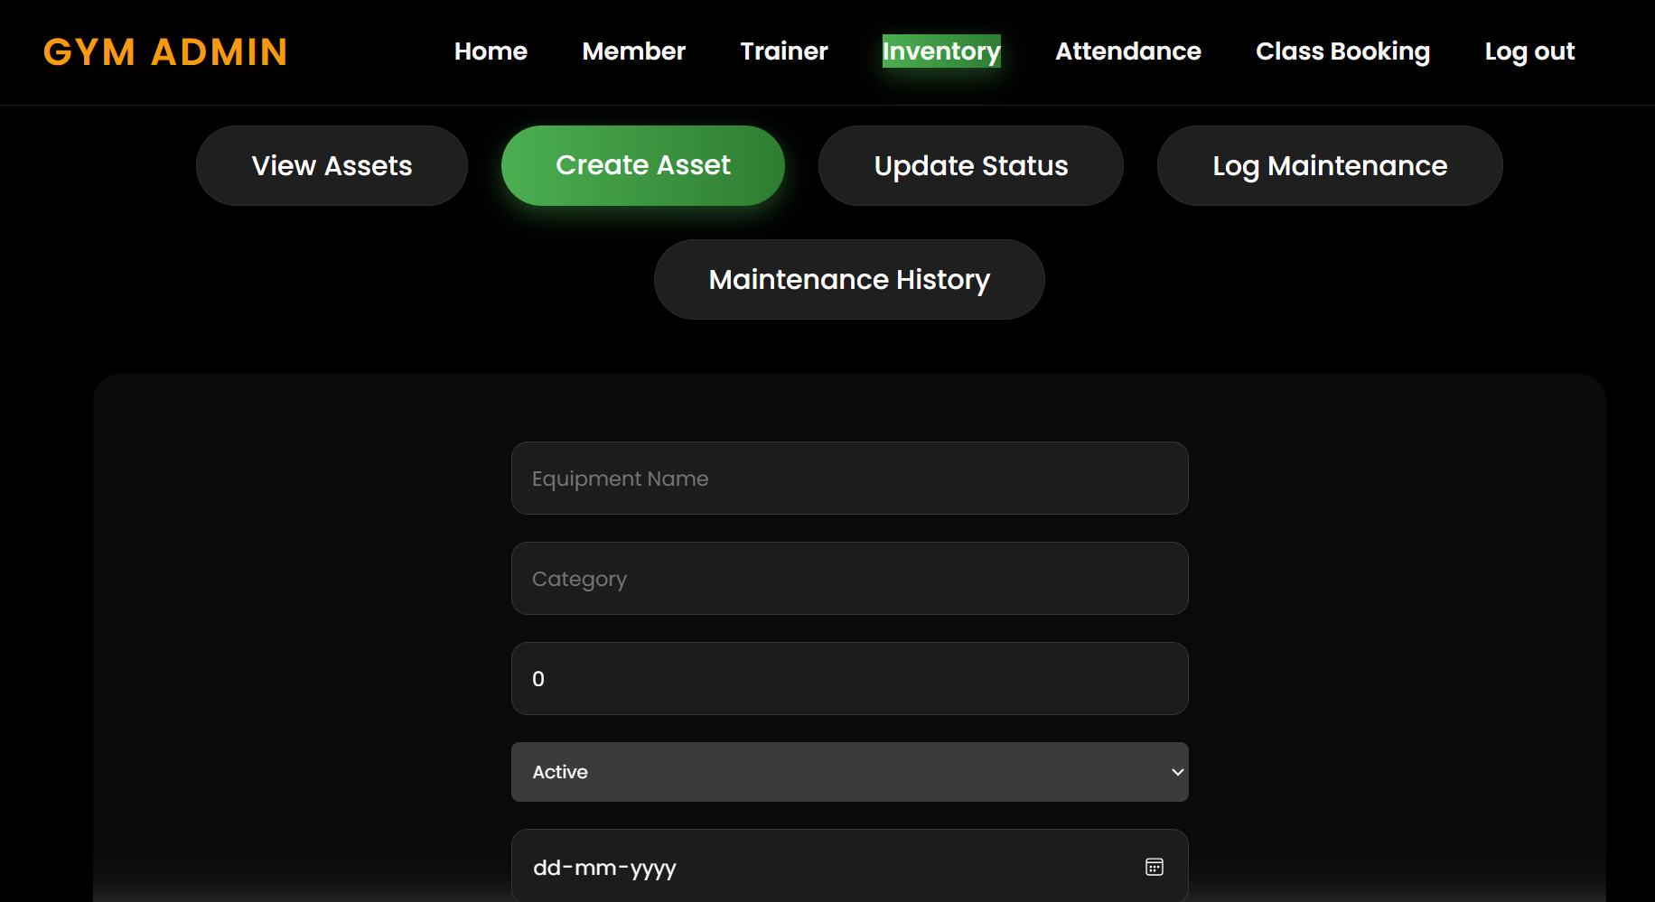
6-Attendance Page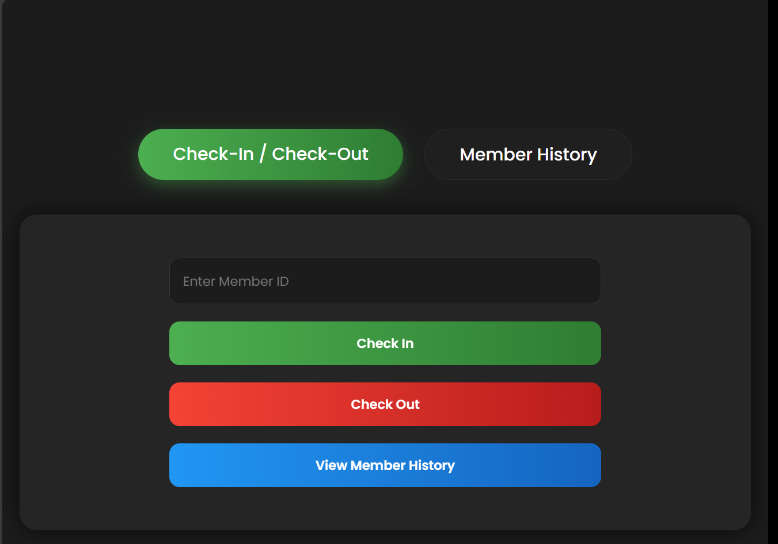

7-Class Booking Page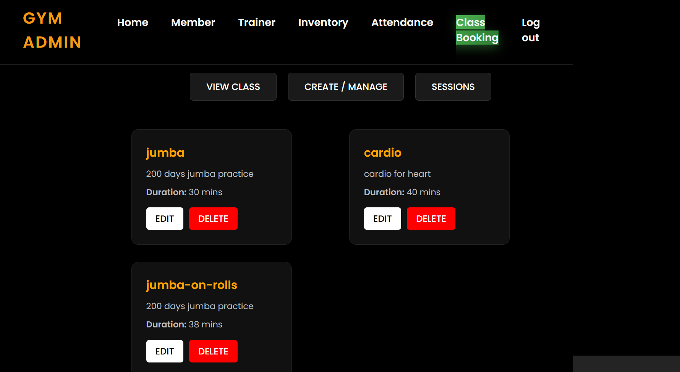

9. Learning Outcomes from the Project
The Gym Management System project provided practical experience in several important software development areas.
Key learnings include:
• Full-stack application development using Java and React
• Designing and implementing REST APIs
• Implementing authentication and authorization using JWT
• Understanding microservices architecture and service communication
• Managing databases using Spring Data JPA and MySQL
• Deploying applications using Docker and AWS cloud infrastructure

Domain Knowledge Training
From 18 February to 3 March, domain training sessions were conducted to introduce interns to the banking and financial services industry.

Retail Lending
Retail lending refers to financial institutions providing loans to individual customers.
Common products include:
- Personal loans
- Credit cards
- Mortgages
- Lines of credit
Banks evaluate borrowers based on credit score, income, debt-to-income ratio, and repayment history to determine loan approval and interest rates.

Personal Loans and Line of Credit
A personal loan is typically an unsecured loan repaid in fixed installments over a specified time period.A line of credit provides a pre-approved borrowing limit that allows customers to withdraw funds as needed.

Credit Cards and Mortgages
Credit cards allow customers to borrow money up to a predefined credit limit and repay it later.
Mortgages are secured loans used to purchase property, where the property itself acts as collateral.

Anti-Money Laundering (AML) and KYC
AML regulations help prevent illegal money from entering the financial system.
Financial institutions implement processes such as:
- Know Your Customer (KYC) to verify customer identity
- Customer Due Diligence (CDD) to monitor financial activities
These measures help detect suspicious transactions and prevent financial crimes.

Financial Risk Management
Financial institutions face different types of risks such as:
- Credit Risk – borrower fails to repay loan
- Operational Risk – failures in internal systems or processes
- Liquidity Risk – inability to meet short-term financial obligations
Banks use various monitoring and regulatory frameworks to manage these risks.

Payment Gateway Systems
A payment gateway enables businesses to accept digital payments securely.
It encrypts payment information and sends it to banks for authorization.
Payment gateways support:
- Credit cards
- Debit cards
- QR payments
- Mobile wallets

Financial Fraud
Financial fraud refers to deceptive practices used to gain financial benefits.
Examples include:
- Identity theft
- Credit card fraud
- Mortgage fraud
- Fake charity scams
Financial institutions use monitoring systems and regulations to detect and prevent fraud.

Agentic AI Training on AWS
From 4 March onwards, I began training in Agentic AI and Generative AI technologies using AWS.
This training follows the AWS Partner Agentic AI Advanced Learning Plan, which focuses on building intelligent AI systems capable of reasoning and performing tasks autonomously.
The learning plan includes theoretical modules, assessments, and practical labs to develop skills in designing scalable AI solutions using AWS services.

Completed Pre-Requisite Courses
Before starting the advanced agentic AI implementation modules, the following prerequisite courses were completed.

Generative AI on AWS (Technical)
This course introduced the applications and lifecycle management of generative AI models within the AWS ecosystem.
Key learning areas included:
- Identifying generative AI business opportunities
- AI model selection and economics
- Model lifecycle management
- Responsible AI practices
AWS services covered:
- Amazon Bedrock
- Amazon SageMaker
- AWS IAM

Agentic AI Essentials
This course explained the evolution from generative AI to agent-based AI systems.
Topics included:
- Autonomous AI agents
- Multi-agent systems
- Agent reliability and limitations
- Business applications of agentic AI
- AWS agentic AI architecture stack

Agentic AI Technical Foundations
This course focused on the technical implementation of AI agents using AWS.
Topics included:
- Agent architecture patterns
- Data foundation design
- AWS AI service selection
- Security and monitoring for AI systems
- Production deployment of AI agents

Current Learning Outcome
Through these courses, I have gained foundational knowledge of:
- Generative AI systems
- Autonomous AI agents
- AI architecture design
- AWS AI and machine learning services
The next phase will involve advanced hands-on implementation of agentic AI solutions.

Professional Certifications and Additional Learning
In addition to the structured training provided during the internship at Incedo Inc. ,I also pursued additional learning and certification courses to enhance my understanding of Artificial Intelligence and cloud technologies.
These courses helped me strengthen my knowledge of AI concepts, prompt engineering techniques, and AWS AI services, which are essential for modern AI-driven software development.

AWS Certified AI Practitioner
During the internship period, I also prepared for the AWS Certified AI Practitioner certification.
This certification focuses on foundational knowledge of Artificial Intelligence, Machine Learning, and Generative AI services within the AWS ecosystem.
The certification training covers key areas such as:
- Fundamentals of Artificial Intelligence and Machine Learning
- Generative AI concepts and applications
- AWS AI and Machine Learning services
- Responsible AI practices
- Security and governance in AI systems
Preparing for this certification helped me understand how AI models and services can be integrated into cloud-based applications to solve real-world business problems.

Prompt Engineering Course (Udemy)
I also completed a course on Prompt Engineering from the Udemy learning platform.
Prompt engineering is an important skill when working with large language models (LLMs) and generative AI systems, as it focuses on designing effective prompts to obtain accurate and useful responses from AI models.

Key concepts learned in this course include:
- Fundamentals of prompt design
- Techniques for improving AI responses
- Role prompting and structured prompts
- Chain-of-thought prompting
- Prompt optimization strategies
- Real-world applications of generative AI tools
This course helped me understand how to interact effectively with AI models and leverage generative AI tools for development, research, and automation tasks.

Challenges Faced
During the internship, a few technical challenges were encountered while learning and implementing new technologies. These challenges were gradually overcome through practice, guidance from mentors, and referring to technical documentation.
• Understanding microservices architecture initially
Initially, it was challenging to understand how multiple independent services interact within a distributed system. With further study and practical implementation, I gained a clearer understanding of service communication and system design.
• Configuring Spring Security and JWT authentication
Setting up authentication and authorization using Spring Security and JWT required careful configuration. Through experimentation and debugging, I learned how to implement secure API access.
• Managing communication between multiple services
Handling communication between microservices using APIs and clients was complex at first. Over time, I understood how services exchange data and maintain proper coordination.
• Deploying applications using Docker and AWS
Deploying applications using Docker containers and AWS cloud services involved learning new tools and configurations. With practice, I became familiar with containerization and cloud deployment processes.
• Learning advanced AI concepts such as agent-based systems
Understanding concepts related to Generative AI and Agentic AI required learning new theoretical and technical concepts. Continuous training and study helped in gaining foundational knowledge in these emerging technologies.

Work to be Done in Remaining Internship Period
During the remaining period of the internship, the focus will be on gaining deeper technical knowledge and applying the concepts learned so far through practical implementation and advanced training.
• Advanced Agentic AI development
Further learning and implementation of advanced concepts related to Agentic AI, including designing and developing autonomous AI agents for enterprise applications.
• Hands-on AI labs using AWS services
Participation in practical labs to gain experience with AWS AI and machine learning services and understand how AI solutions are implemented in cloud environments.
• Implementation of AI-powered enterprise applications
Working on building applications that integrate AI capabilities to automate tasks and support intelligent decision-making in enterprise systems.
• Further improvements to full-stack application projects
Enhancing existing full-stack projects by improving features, optimizing performance, and implementing additional functionalities.
• Learning advanced cloud and DevOps practices
Continuing to develop knowledge of cloud deployment, containerization, and DevOps tools to improve application development and deployment workflows.

Bottom of Form

Conclusion
The first phase of the internship at Incedo Inc. has been a valuable learning experience.
The structured training program provided exposure to Java full stack development, microservices architecture, cloud technologies, and financial industry domain knowledge.
The hands-on project and AI training helped in understanding how modern enterprise systems are designed and deployed.
The ongoing Agentic AI training on AWS is further expanding my knowledge in emerging technologies that are transforming the future of software development.
This internship is helping me develop both technical expertise and industry knowledge required for a career in software engineering and AI-driven systems.

References
- Java Official Documentation
- Spring Boot Documentation
- React Documentation
- AWS Training and Certification Materials
- Docker Documentation
- Incedo Training Resources

